

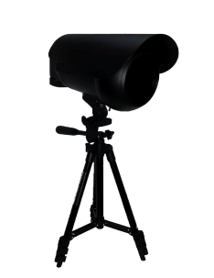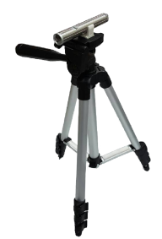 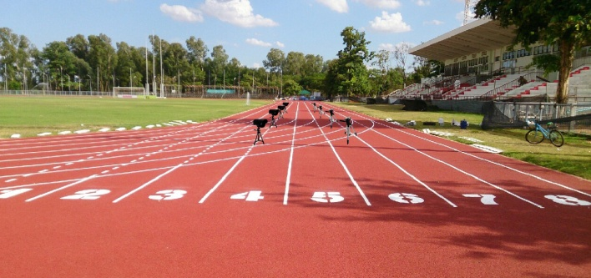

**Scientific Invention**

**SPEED ANALYSER**

**Created by**

**Chomtana Chanjaraswichai M.6/1**

**Kittiphum Prasitchaipan M.4/4**

**Kanchanapisek Wittayalai Nakhonpathom School (Pratumnak Suankularb Mattayom)**

**Nakhon Pathom province**

**Under the Office of the Secondary Education Region 9**

**Office of the Basic Education Commission**  
**Ministry of Education**



**Scientific Invention**

**SPEED ANALYSER**

**Created by**

**1. Chomtana Chanjaraswichai M.6/1**

**Birthday May, 1st 2000 age 17 years old**

**2. Kittiphum Prasitchaipan M.4/4**

**Birthday August, 25th 2002 age 14 years old**

**Advisors**

**1. Mr.Chanchai Chanlit**

**2. Mrs.Orawan Sathongyoo**

**Kanchanapisek Wittayalai Nakhonpathom School**

**(Pratumnak Suankularb Mattayom)**

**Nakhon Pathom province**

**Tel. 081 – 7706252 Fax.034 - 297664**

**E – mail : rabbit_oil@hotmail.com**

**Under the Office of the Secondary Education Region 9**

**Office of the Basic Education Commission, Ministry of Education**

**1. Abstract**

Speed analyser is a scientific invention for testing motor fitness in running speed. Speed analyser will return time used to run from start to the speed analyser. This research develops speed analysers to test motor fitness in running speed in 50 meters distance. In this research, four speed analysers are installed in 15, 30, 40 and 50 meters distance. Time recorded from speed analyser is used to calculate speed and formulate fitness training program which is a part of health care planning. Speed analyser is an innovation that uses a lot of knowledge and academic principles which are a part of STEM education which includes science, technology, engineering and mathematic. Moreover, researchers have adopted other academic principles such as the knowledge of physical fitness test and physical fitness training in the field of physical education and health to build speed analyser. Speed analyser use materials that cheap and can be found easily in markets. Some parts of the speed analyser are teaching equipments. Speed analyser is made to replace general stopwatch that requires timekeeper and inaccurate.

Speed analysers are evaluated by comparing recorded times of 10 participants between speed analysers and stopwatches. Researchers found that speed analysers have high accuracy because times from speed analysers are comparable with times from stopwatches. The result from testing all participants show that average running speed in 0 – 15 meter is 5.82 m/s, 15 – 30 meter is 6.67 m/s, 30 – 40 meter is 6.98 m/s, and 40 – 50 meter is 7.13 m/s. Next, researchers will use these average speeds to formulate fitness training program for each participant.

**2. Background/Concept/Inspiration for Creativity**

Because of researchers have studied health and physical education in mattayom 4 in 2015 about physical fitness, testing health related fitness, motor fitness and physical fitness training. Motor fitness include agility, balance,   
co-ordination, power, reaction time and speed. Each type of motor fitness have unique testing method. In present, motor fitness in speed can be tested by using only one stopwatch at finishing point so that only one overall time will be recorded. From studing show that in short distance running speed pattern in different distance will be different so that ony one overall time cannot be used as motor fitness testing method.

From that problem, researchers think about how to solve that problem, so researchers try to record time in four distance include 15 meters, 30 meters, 40 meters and 50 meters. In beginning, researchers use four stopwatches to record times but our advisors advise that stopwatches may be inaccuracy, so that researchers try to solve this new problem. Researchers solve this new problem by building speed analyser which use ldr sensor and laser to stop stopwatch instead of timekeeper. Using ldr sensor and laser to stop stopwatch is likely more accuracy, so that researchers build speed analyser that use this technique to solve all problems and create high efficiency motor fitness in speed testing method.

**3. Objective**

1. To design and create speed analyser**.**

2. To study the performance of speed analyser.

**4. Material used**



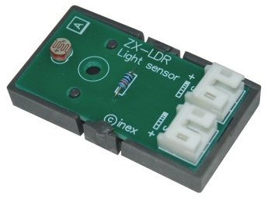

**5.2 ZX-LDR**

**5.1 IPST-Microbox**

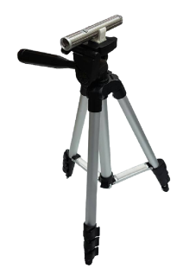

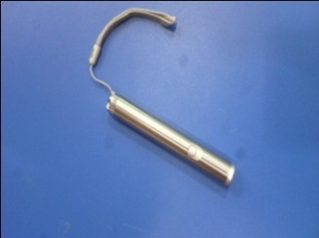

**5.3 Laser pointers**

**5.4 Tripods with laser pointers**

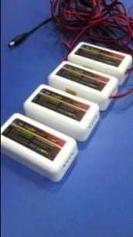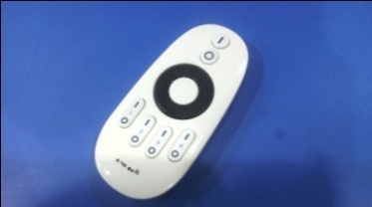

**5.5 Remote signal receiver (Mi-Light)**

**ไฟ**

**5.6 Remote**

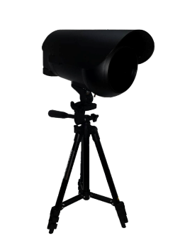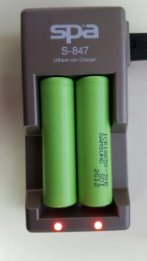

**5.8 Camera housing box**

**5.7 3V rechargeable battery**

**ไฟ**

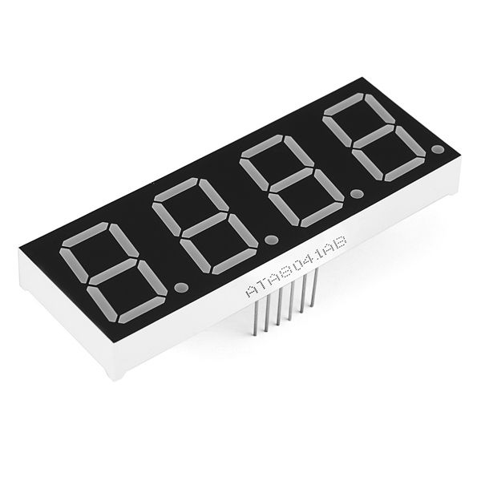

**5.9 7-Segment display**

**5. Budget**

1. 4 Laser pointers, 60 THB each, total 240 THB.
2. 4 Remote signal receivers (Mi-Light), 400 THB each, total 1,600 THB.
3. 1 Remote, 300 THB each, total 300 THB.
4. IPST – Microboxs borrowed from department of computer.
5. Tripods borrowed from department of audiovisual.

**Total 2,140 THB**

**6. Process of building and how to use speed analyser**

**6.1 Designing and building speed analyser process**

1. Study related document.
2. Study information about process of speed analyser.
3. Study information about materials that used to build speed analyser.
4. Study information about how to position speed analyser in testing.
5. Create flowchart that show process of program in IPST-Microbox.
6. Program IPST-Microbox by following this step.
   1. Write program according to flowchart that created in step 5.
   2. Compile written program.
   3. Connect IPST-Microbox to computer and program IPST-Microbox.
7. Install speed analyser components.
8. Test speed analyser in simulating room.
9. Test speed analyser in real place.

**6.2 Speed analyser evaluation process and motor fitness in running speed in 50 meters distance testing process**

1. Order 4 timekeepers to stand in 15, 30, 40, 50 meters distance and order speed analyser starter to stand in 50 meters distance.
2. Order a participant to move to starting point.
3. Signal the participant to start running. When the timekeepers and the speed analyser starter hear the signal, the speed analyser starter will start speed analyser and the timekeepers will start their stopwatches.
4. When the participant move through each defined distances that are 15, 30, 40 and 50 meter, timekeeper in each distance must stop her stopwatches.
5. Record times that the speed analysers show and times of each timekeeper.
6. Repeat step 2 to 5 for each participant until all participants are tested. When all participant are tested, test all participants again.
7. Calculate error between times recorded from each timekeeper and speed analysers.
8. Use recored times to calculate running speed of each participant and then use calculated running speed to create fitness training program for each participant.

**6.3 How to use speed analyser**

1. Place speed analysers in positions according to this chart below.



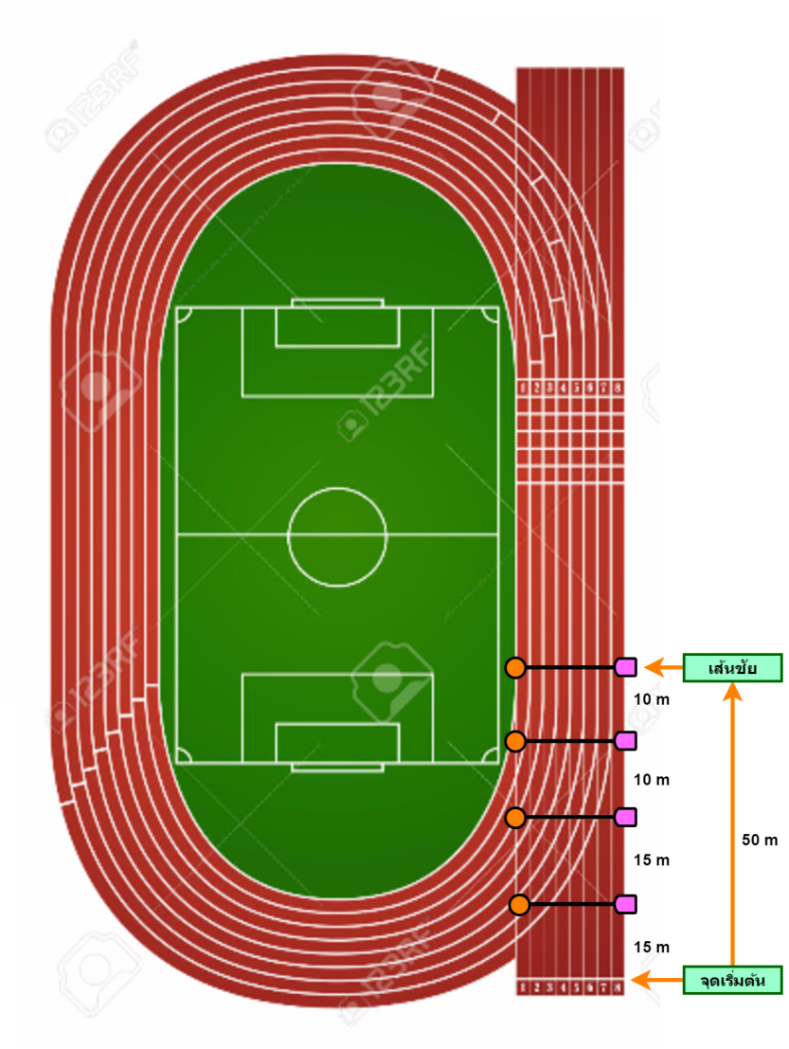

1. Turn on all speed analysers.
2. Make sure all speed analysers still not running, if not use remote to reset and pause all speed analysers.
3. Order a participant to move to starting point.
4. Signal the participant to start running (Get set – Ready - Go) and use remote to start all speed analysers.
5. Wait until the participant run to finishing line.
6. Record times that the speed analysers show.
7. Use remote to reset and pause all speed analysers.
8. Repeat step 3 to 8 for each participant until all participants are tested.
9. Use recored times to calculate running speed of each participant and then use calculated running speed to create fitness training program for each participant.

**8. Charts**



**Speed analyser positioning chart**

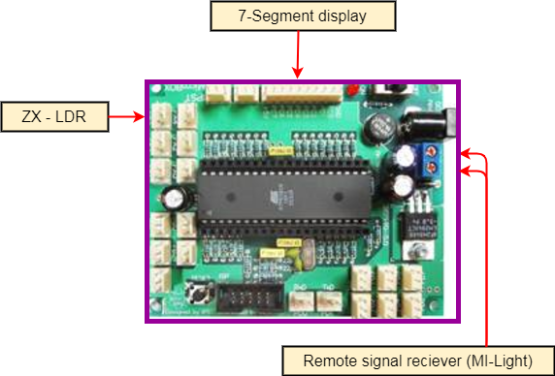

**Speed analyser IPST-Microbox connection chart**

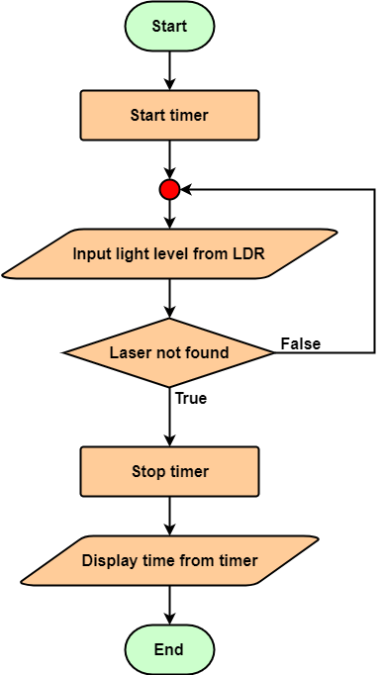

**Flowchart that show how program in IPST-Microbox work**

**9. Results**

**Table 1 show time and speed in 0 – 15 meters running distance recorded from stopwatch and speed analyser**

|  |  |  |  |  |
| --- | --- | --- | --- | --- |
| Participant No. | Stopwatch | | Speed analyser | |
| Time (s) | Speed (m/s) | Time (s) | Speed (m/s) |
| 1. | 2.77 | 5.42 | 2.53 | 5.93 |
| 2. | 2.90 | 5.17 | 2.86 | 5.24 |
| 3. | 2.43 | 6.17 | 2.31 | 6.49 |
| 4. | 2.33 | 6.44 | 2.29 | 6.55 |
| 5. | 2.38 | 6.30 | 2.64 | 5.68 |
| 6. | 2.53 | 5.93 | 2.76 | 5.43 |
| 7. | 2.79 | 5.38 | 2.81 | 5.34 |
| 8. | 2.55 | 5.88 | 2.67 | 5.62 |
| 9. | 2.58 | 5.81 | 2.75 | 5.45 |
| 10. | 2.51 | 5.98 | 2.34 | 6.41 |
| Average | 2.58 | 5.85 | 2.60 | 5.82 |

**Table 2 show time and speed in 0 – 30 meters running distance recorded from stopwatch and speed analyser**

|  |  |  |  |  |
| --- | --- | --- | --- | --- |
| Participant No. | Stopwatch | | Speed analyser | |
| Time (s) | Speed (m/s) | Time (s) | Speed (m/s) |
| 1. | 4.08 | 7.35 | 4.33 | 6.93 |
| 2. | 4.94 | 6.07 | 4.86 | 6.17 |
| 3. | 4.30 | 6.98 | 4.31 | 6.96 |
| 4. | 4.36 | 6.88 | 4.19 | 7.16 |
| 5. | 4.59 | 6.54 | 4.57 | 6.56 |
| 6. | 4.84 | 6.20 | 4.64 | 6.47 |
| 7. | 4.90 | 6.12 | 4.85 | 6.19 |
| 8. | 4.77 | 6.29 | 4.49 | 6.68 |
| 9. | 4.61 | 6.51 | 4.50 | 6.67 |
| 10. | 4.41 | 6.80 | 4.37 | 6.86 |
| Average | 4.58 | 6.57 | 4.51 | 6.67 |

**Table 3 show time and speed in 0 – 40 meters running distance recorded from stopwatch and speed analyser**

|  |  |  |  |  |
| --- | --- | --- | --- | --- |
| Participant No. | Stopwatch | | Speed analyser | |
| Time (s) | Speed (m/s) | Time (s) | Speed (m/s) |
| 1. | 5.37 | 7.45 | 5.49 | 7.29 |
| 2. | 5.94 | 6.73 | 6.17 | 6.48 |
| 3. | 5.53 | 7.23 | 5.47 | 7.31 |
| 4. | 5.43 | 7.37 | 5.29 | 7.56 |
| 5. | 6.24 | 6.41 | 5.91 | 6.77 |
| 6. | 6.31 | 6.34 | 6.01 | 6.66 |
| 7. | 6.23 | 6.42 | 6.15 | 6.50 |
| 8. | 5.99 | 6.68 | 5.71 | 7.01 |
| 9. | 5.94 | 6.73 | 5.71 | 7.01 |
| 10. | 5.33 | 7.50 | 5.53 | 7.23 |
| Average | 5.83 | 6.89 | 5.74 | 6.98 |

**Table 4 show time and speed in 0 – 50 meters running distance recorded from stopwatch and speed analyser**

|  |  |  |  |  |
| --- | --- | --- | --- | --- |
| Participant No. | Stopwatch | | Speed analyser | |
| Time (s) | Speed (m/s) | Time (s) | Speed (m/s) |
| 1. | 6.71 | 7.45 | 7.08 | 7.06 |
| 2. | 7.09 | 7.05 | 7.38 | 6.78 |
| 3. | 6.55 | 7.63 | 6.63 | 7.54 |
| 4. | 6.94 | 7.20 | 6.62 | 7.55 |
| 5. | 7.41 | 6.75 | 7.27 | 6.88 |
| 6. | 7.31 | 6.84 | 7.24 | 6.91 |
| 7. | 7.37 | 6.78 | 7.48 | 6.68 |
| 8. | 6.88 | 7.27 | 6.93 | 7.22 |
| 9. | 7.12 | 7.02 | 6.95 | 7.19 |
| 10. | 7.45 | 6.71 | 6.69 | 7.47 |
| Average | 7.08 | 7.07 | 7.03 | 7.13 |

**Table 5 show running speed in each distance recorded from speed analyser**

|  |  |  |  |  |
| --- | --- | --- | --- | --- |
| Participant No. | Speed in each distance (m/s) | | | |
| 0 – 15 m | 15 – 30 m | 30 – 40 m | 40 – 50 m |
| 1. | 5.93 | 6.93 | 7.29 | 7.06 |
| 2. | 5.24 | 6.17 | 6.48 | 6.78 |
| 3. | 6.49 | 6.96 | 7.31 | 7.54 |
| 4. | 6.55 | 7.16 | 7.56 | 7.55 |
| 5. | 5.68 | 6.56 | 6.77 | 6.88 |
| 6. | 5.43 | 6.47 | 6.66 | 6.91 |
| 7. | 5.34 | 6.19 | 6.50 | 6.68 |
| 8. | 5.62 | 6.68 | 7.01 | 7.22 |
| 9. | 5.45 | 6.67 | 7.01 | 7.19 |
| 10. | 6.41 | 6.86 | 7.23 | 7.47 |
| Average | 5.82 | 6.67 | 6.98 | 7.13 |

**Chart 1 show speed of 1st participant in each distance**

**Chart 2 show speed of 2nd participant in each distance**

**Chart 3 show speed of 3rd participant in each distance**

**Chart 4 show speed of 4th participant in each distance**

**Chart 5 show speed of 5th participant in each distance**

**Chart 6 show speed of 6th participant in each distance**

**Chart 7 show speed of 7th participant in each distance**

**Chart 8 show speed of 8th participant in each distance**

**Chart 9 show speed of 9th participant in each distance**

**Chart 10 show speed of 10th participant in each distance**

**Chart 11 show speed of all participants in each distance**

**1st person**

**2nd person**

**3rd person**

**4th person**

**5th person**

**6th person**

**7th person**

**8th person**

**9th person**

**10th person**

**9. Appendix**

**Speed analyser invention process.**

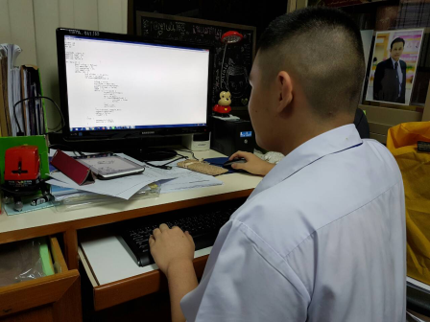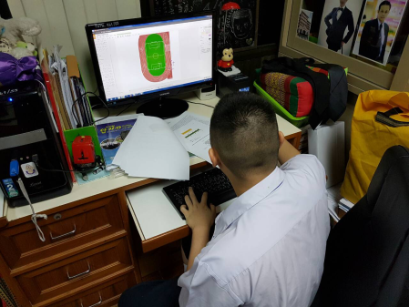

**1. Write program for IPST-Microbox.**

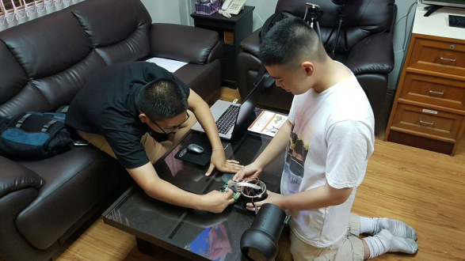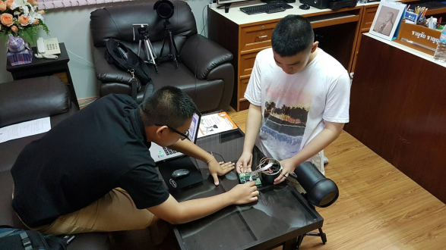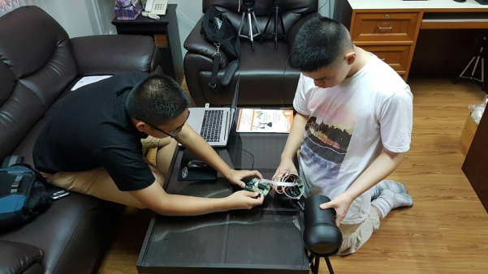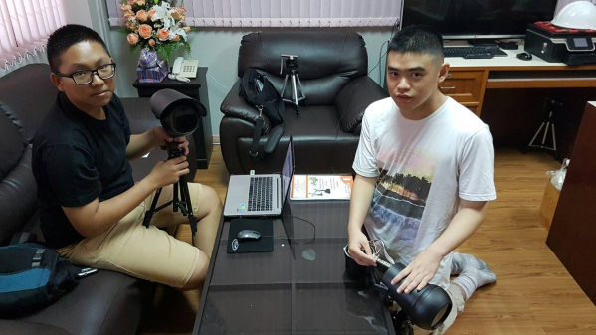

**2. Install speed analyser components into the camera housing box.**

**Position of speed analysers in 4 distances.**

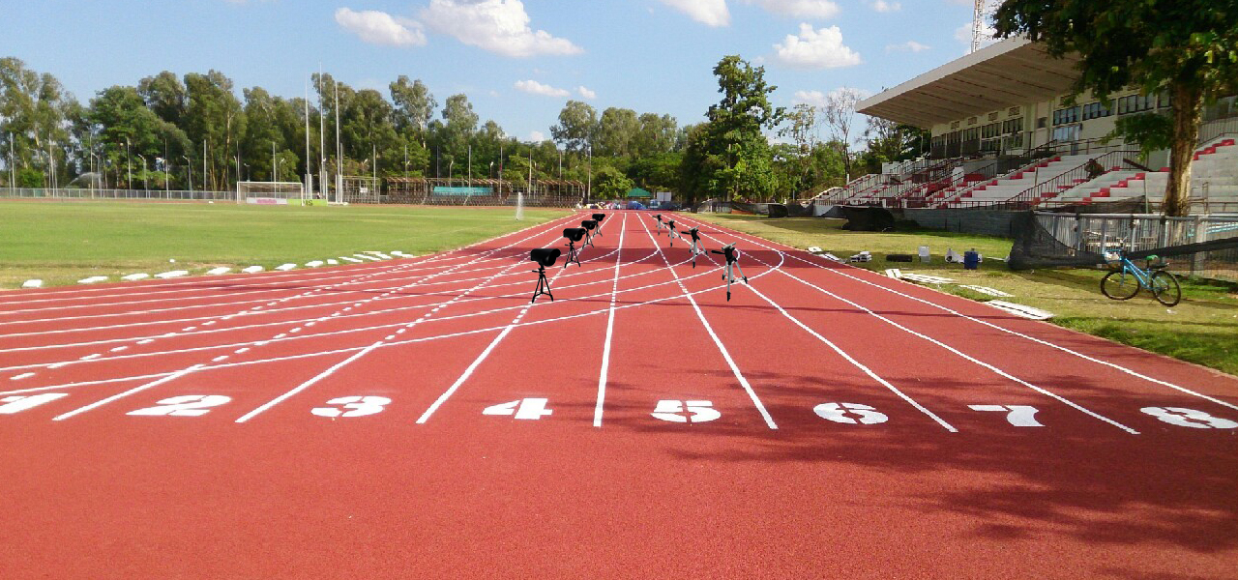

**Samples in the experimnt.**

